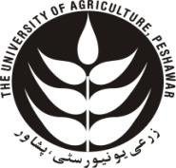
UNIVERSITY MAIN STORE
The University of Agriculture Peshawar
Ph: (091) 922-1166/922-1304, Ext. 3191
Fax: (091) 922-1262

No. |  | /UMS/FD |  | Dated:

